1.what are vanilla autoencoders ?

Ans : Autoencoder is a type of neural network that can be used to learn a compressed representation of raw data.& vanilla autoencoder is a three layers net a neural net with one hidden layer. The input and output are the same.

2.what are Sparse autoencoders ?

Ans : A sparse autoencoder is one of a range of types of autoencoder artificial neural networks that work on the principle of unsupervised machine learning.

3.what are Denoising autoencoders?

Ans : Denoising Autoencoder is a modification on the autoencoder to prevent the network learning the identity function.

4 what are convolutional autoencoders?

Ans : Convolutional Autoencoder is a variant of Convolutional Neural Networks that are used as the tools for unsupervised learning of convolution filters.

5.what are stacked autoencoders ?

Ans : Stacked Autoencoders is a kind of unsupervised learning structure that owns three layers: input layer, hidden layer, and output layer.

6 Explain how to generate sentences using LSTM autoencoders.

Ans :

An LSTM Autoencoder is an implementation of an autoencoder for sequence data using an Encoder-Decoder LSTM architecture.

Once fit, the encoder part of the model can be used to encode or compress sequence data that in turn may be used in data visualizations or as a feature vector input to a supervised learning model.

you will discover the LSTM Autoencoder model and how to implement it in Python using Keras.

Autoencoders are a type of self-supervised learning model that can learn a compressed representation of input data.

LSTM Autoencoders can learn a compressed representation of sequence data and have been used on video, text, audio, and time series sequence data.

How to develop LSTM Autoencoder models in Python using the Keras deep learning library.

7.Explain extractive summarization

Ans : Extractive summarization is identifying the salient information that is then extracted and grouped together to form a concise summary.This technique involves the extraction of important words/phrases from the input sentence.

8.Explain Abstractive summarization.

Ans: Abstractive summarization is the technique of generating a summary of a text from its main ideas, not by copying verbatim most salient sentences from text.

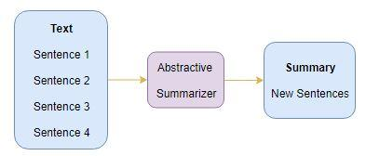

This technique involves the generation of entirely new phrases that capture the meaning of the input sentence.

9.Explain Beam search

Ans : Beam search is the sequence to sequence Deep NLP algorithms like Neural Machine Translation, Image captioning, Chatbots, etc.

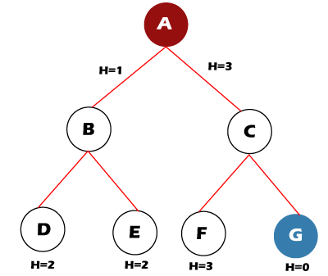

beam search is most often used to maintain tractability in large systems with insufficient memory to store the entire search tree.

10.Explain Length normalization.

Ans : Length normalization is divide number of occurrences by the length of the document. For example, we can measure the length in pages and divide the number

11.Explain coverage normalization.

Ans :coverage normalization is an approach which is applied during the preparation of data in order to change the values of numeric columns in a dataset to use a common scale when the features in the data have different range.

12.Explain ROUGE metric evaluation.

Ans : ROUGE stands for Recall-Oriented Understudy for Gisting Evaluation. It is essentially a set of metrics for evaluating automatic summarization of texts as well as machine translations. rogue value (terminator, sentinel) A value added at the end of a table and that can be recognized as a termination signal by a table lookup program.